Mandala Designs
Author: Lisa Offiler
Subject: Art 7
Interval: Quarter Class
Time: 5-7 Classes

Overview
In an effort to connect with the Social Studies Curriculum, students in grade 7 will learn about the East Asian tradition of the Mandala. Students will understand the role of the Mandala in these cultures. From an artistic viewpoint, students will learn how radial balance can lead to a unified and balanced effect in art. Students will design and create their own Mandala using geometric and organic shapes.

Objectives
As a result of instruction, students will

- Visual Arts Anchor Standard #1: Generate and conceptualize artistic ideas and work
  - Generate ideas for a Mandala design using radial balance, organic shapes, and geometric shapes
- Visual Arts Anchor Standard #11: Relate artistic ideas and works with societal, cultural, and historical context to deepen understanding.
  - Connect personal artwork to historic and cultural context of Mandalas

Activities
- Students will view the following video on YouTube (https://www.youtube.com/watch?v=ga5s_qYgJS8) of Buddhist monks creating and destroying a Mandala form.
- Students will discuss the example Mandala, and focus on the terms radial balance and geometric and organic shapes. Students will define these terms in their sketchbooks.
- Students will be shown the process of creating their Mandala – designing one section, transferring the design using tracing paper and pencil, and outlining in Sharpie.
- Once their quarter design is ready, it will be photocopied four times. Students will color the portions of their Mandala using colored pencil. An emphasis on radial balance is added here. Coloring should be uniform to lead to the sense of radial balance. To add further dimension and interest, they will add shading to at least one portion to their Mandala.
- Students will cut and assemble Mandalas onto 18”x18” white oak tag. As a final touch, they may choose to add metallic paint to emphasize a particular part of their Mandala.

Adaptations
Students with special needs may only complete one section of their Mandala. Instead of using the tracing paper method of copying the section, their design will be photocopied 12 times instead of 4. They may cut and assemble their Mandala into a circle.

Evaluation
See attached project checklist.

Materials
- Mandala quarter handout
- Tracing paper
- Pencil
- Sharpie
- Access to photocopier
- Colored pencils
- Scissors
- Glue
- 18”x18” Oak tag
- Optional: Metallic Paint

Other Resources
You Tube Video: https://www.youtube.com/watch?v=ga5s_qYgJS8

Performance Task: Mandala Design

Student Name:
Project Criteria | Possible Points | Self Evaluation | Teacher Evaluation
Elements and Principles of Design:  Considers the elements and principles of creative design in your Mandala composition.  Plans design in regards to the edges and corners of Mandala section.  Uses both organic and geometric designs.  Demonstrates understanding of radial balance as evident in final work. | 30
Creativity and Critical Thinking:  Student has produced a unique solution to the visual design problem.  Evidence of personality was incorporated into your design. | 30
Craftsmanship:  Artwork is neat and shows concern for excellence in final presentation. | 20
Reflection:  Artwork demonstrates evidence of revision, reflection, and thoughtfulness. | 10
Completion:  Student created a fully colored Mandala.  All sections of Mandala are cut and glued appropriately. | 10

Comments:

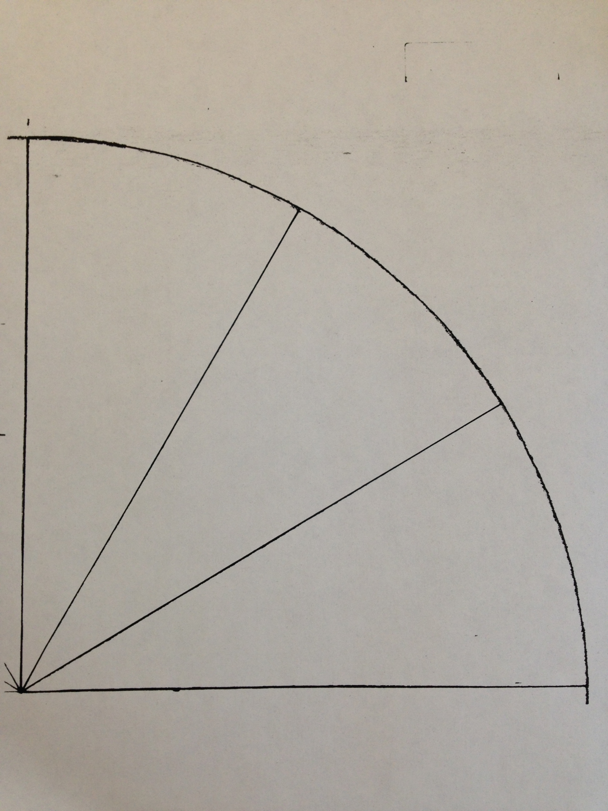
Quarter Circle – Mandala Design

